Contents
IFP_PO_RECEI_INBOU_INTEG_ATP — Full Technical Analysis 2
Section 1 — Project Overview 2
Section 2 — Connection Registry 2
Section 3 — Pipeline Architecture (7 Core Flows) 4
Section 4 — Per-Flow Technical Detail 5
F1 · UPDA_IFP_EAM_PO_RECE_DATA_EXTR_I — Data Extraction 5
F2 · IFP_EAM_PO_RECE_BATC_PROC_INTE — Batchwise Dispatcher 6
F3 · IFP_EAM_PO_RECEIPT_STAG_DATA_LOA — Stage Data Loading 8
F4 · IFP_EAM_PO_RECEIPT_VALID_INTEG — Validation 9
F5 · IFP_EAM_PO_IMPORT_INTEGR — FBDI Import 11
F6 · IFP_PO_RECEI_IMPOR_CALLB_REQUE — ERP Import Callback 13
F7 · IFP_EAM_UPDA_MESS_IN_EAM_HEXA — EAM Writeback 15
Section 5 — Reprocess and Manual-Trigger Flows (4 Flows) 17
Section 6 — ATP Stored Procedure Inventory 18
Section 7 — Implementation Issues and Defects 20
Section 8 — Comparison with IFP_PO_INBOUN_INTEGR_ATP 21

IFP_PO_RECEI_INBOU_INTEG_ATP — Full Technical Analysis

Section 1 — Project Overview
Package: IFP_PO_RECEI_INBOU_INTEG_ATP (IFP PO Receipt Inbound Integration)
OIC Version: 26.01 · Revision 2620 · Last updated 2026-05-07
Style: App-Driven Orchestration + Scheduled Orchestration + Subscribed Orchestration
Total Flows: 11 (7 pipeline, 4 reprocess/manual-trigger)
Business purpose: Extracts PO Receipt transactions from the EAM 3rd-party ERP system, stages and validates them in ATP, submits them to Oracle ERP Fusion via FBDI, processes the ERP import callback, and writes success/error results back to EAM — mirroring the structure of IFP_PO_INBOUN_INTEGR_ATP but for receipts rather than purchase orders.

Section 2 — Connection Registry
Connection ID | Name | Type | Usage
IFP_PO_RECEI_ATP_DB_CONNE | IFP PO Receipt ATP DB Connection | ATP DB / JDBC_OVER_SSL | All ATP staging, validation, status, logging procedures
IFP_PO_RECEI_EAM_REST_CONNE | IFP PO Receipt EAM REST Connection | REST / BASIC_AUTH | EAM grid extracts (F1) and EAM writeback APIs (F7)
IFP_PO_RECE_ORAC_ERP_CLOU_CONN | IFP PO Receipt Oracle ERP Cloud Connection | ERP Cloud adapter | FBDI importRcptsToERP (F5), ESS callback poimportorderscallback (F6), ZIP download (F6)
IFP_PO_RECE_ORAC_BIP_SOAP_CONN | IFP PO Receipt Oracle BIP Soap Connection | SOAP / UsernameToken | BIP validation reports (F4), BIP import result reports (F6)
IFP_PO_RECEI_OIC_REST_CONNE | IFP PO Receipt OIC REST Connection | REST (OIC self-REST) | Internal endpoint for collocated chain entry points (F3, F4, F5) and all reprocess flows
APPLICATION_EVENT_CONNECTION | Application Event Bus | OIC AppEvent | Publishes/subscribes CALLPRIORITYWISEPORCPT and UPDATEERRORINEAMHEXAGON events
PRESEEDED_COLLOCATED_CONN_1741 | Local Integration | OIC Collocated | Synchronous child-flow invocations (F2→F3, F3→F4, F4→F5)

AppEvent types:

Event | Publisher(s) | Subscriber(s) | Purpose
CALLPRIORITYWISEPORCPT | F1, F6, IFP_EAM_PRIORITY_REPROCES, IFP_PO_RECEI_IMPOR_CALLB_REPRO | F2 | Triggers batchwise processing pipeline
UPDATEERRORINEAMHEXAGON | F5, F6, IFP_PO_RECEI_IMPOR_CALLB_REPRO, IFP_EAM_UPDA_MESS_IN_EAM_HEXA_RE | F7 | Triggers EAM writeback

Section 3 — Pipeline Architecture (7 Core Flows)
The pipeline follows the same 3-tier collocated chain + AppEvent pattern as IFP_PO_INBOUN_INTEGR_ATP, but the receipt process extracts 5 grid types from EAM (vs 2 in PO Inbound) and uses a priority-based batch dispatch system.

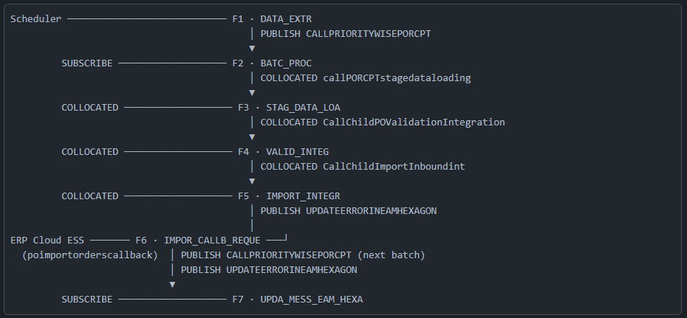

Section 4 — Per-Flow Technical Detail

F1 · UPDA_IFP_EAM_PO_RECE_DATA_EXTR_I — Data Extraction
Trigger: OIC Schedule (scheduleReceive)
Tracking: startTime (primary) — tracking_var_2/3 unused
Connections used: IFP_PO_RECEI_EAM_REST_CONNE, IFP_PO_RECEI_ATP_DB_CONNE, APPLICATION_EVENT_CONNECTION

Orchestration — DataExtractionEAMScope [try t0]:
The extraction runs 5 independent WHILE-paginated EAM grid fetches in sequence, each with its own CATCH_ALL exception handler that writes to a specific ATP exception proc and sends an email notification. This is a stronger fault isolation model than PO Inbound's 2 grids.

Sub-scope | EAM REST Operation | ATP Insert | CATCH_ALL Proc
HeaderReceiveExtractGrid [try t2] | FetchReceiveGridDetails (REST1) | EAMReceiveHdrInsert (ATP1) | ReceiveHeaderException (ATP9)
LineReceiveExtractGrid [try t4] | FetchReceiveLineGridDetails (REST2) | EAMRecieveLineInsert (ATP2) [note: Recieve typo] | ReceiveLineException (ATP10)
HeaderReturnExtractGrid [try t6] | FetchRtnHdrGridDetails (REST3) | EAMReturnHdrInsert (ATP3) | ReturnHeaderException (ATP11)
LineReturnExtractGrid [try t8] | FetchRtnLineGridDetails (REST4) | EAMReturnLineInsert (ATP4) | ReturnLineException (ATP12)
RecptServiceExtraGrid [try t10] | fetchServiceRecReturnGrid (REST5) | InsertServiceStageloaddata (ATP5) | ServiceException (ATP13

After all 5 grids extract:
PORCPTbatchCreation [try t1] (runs AFTER all 5 grids, same order pattern as PO Inbound):
- ATP Insertintoextractloadtable (ATP6) — record in load tracking table
- ATP poRcptinboundbatchupdcre (ATP7) — create the batch record
- CATCH_ALL: ATP BatchCreationException (ATP14) → ehStop
callprioritywise [try t3]:
- ATP PORCPTprior (ATP8) — set priority for this batch
- Assignments: AssignBatchIDandPriority (a24, a25)
- STITCH sh0
- PUBLISH CALLPRIORITYWISEPORCPT AppEvent (fire-and-forget)
- CATCH_ALL: ehStop
Global CATCH_ALL: Email notification → ehStop
ACTIVITY_STREAM_LOGGER lg0 fires at start (before scopes).
Key difference from PO Inbound F1: 5 grid types vs 2; poRcptinboundbatchupdcre (vs POinboundbatchcreation); dedicated PORCPTprior priority-setting step before AppEvent publish; BatchCreationException stored proc for rollback (cleaner than PO Inbound which had Deletedatafromstagingtable).

F2 · IFP_EAM_PO_RECE_BATC_PROC_INTE — Batchwise Dispatcher
Trigger: SUBSCRIBE CALLPRIORITYWISEPORCPT AppEvent
Tracking: p_new_batch_id (primary), p_new_priority_col

Orchestration:
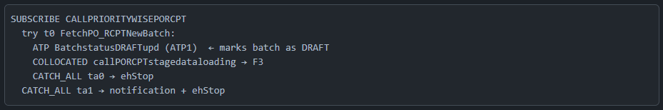
⚠ Issue: The inner CATCH_ALL at ta0 does only ehStop with no logging or ATP error recording. A collocated failure from F3→F4→F5 propagating back will be silently terminated here. Only the global CATCH_ALL ta1 sends a notification.

F3 · IFP_EAM_PO_RECEIPT_STAG_DATA_LOA — Stage Data Loading
Trigger: REST callpostagerest via collocated from F2
Tracking: pbatchId (primary), poicintid
Orchestration:
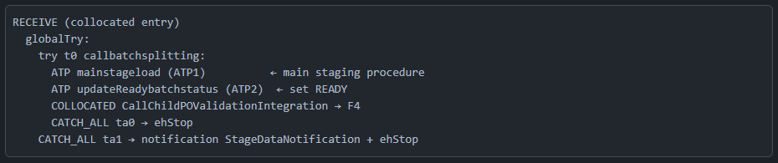This flow calls two ATP procedures before invoking F4. The mainstageload procedure consolidates the raw EAM grid data into the working staging structure. updateReadybatchstatus marks it READY before validation begins.

⚠ Issue: Same pattern as F2 — inner CATCH_ALL ta0 has no ATP error recording, just ehStop. Failures from the F4→F5 collocated chain propagate back here and terminate silently at the inner level.

F4 · IFP_EAM_PO_RECEIPT_VALID_INTEG — Validation
Trigger: REST POIntevalidation push-sync (request-reply) via collocated from F3
Flags: projectHasWarnings: true (OIC exported with warnings)
Connections used: IFP_PO_RECE_ORAC_BIP_SOAP_CONN, IFP_PO_RECEI_ATP_DB_CONNE, PRESEEDED_COLLOCATED_CONN_1741

Orchestration — BIPreportcall [try t0]:
- ATP fecthBUbatchlastrundetails (Oracle ATP1) — fetch BU last-run timestamps [⚠ same fecth typo as PO Inbound — this is the same shared procedure name pattern]
- FOR each BU [f0]:
  - Assignment Setreportrundate (a7)
  - BIPcallPOreceipt [try t3]: BIP SOAP POreceiptreport → stageFile sf3 → ROUTER sc0 → stageFile sf6 (segment read) → ATP POreceipt (ATP2) — named SOAP4 in flow
  - BIPcallSupplierReport [try t2]: BIP SOAP BIPgetsupplierReport → stageFile sf2 → ROUTER sc1 → stageFile sf5 (segment read) → ATP loadPOsupplierdet (ATP3) — named SOAP2 in flow
  - BIPCallinvItemReport [try t4]: BIP SOAP BIPgetInvItemReport → stageFile sf4 → ROUTER sc2 → stageFile sf7 (segment read) → ATP loadInvItemdetailsrpt (ATP4) — named SOAP4 in flow
  - ATP updatelastrundate (ATP5)
⚠ DEFECT — duplicate operation names: The two BIP calls POreceiptreport and BIPgetInvItemReport are both labeled name="SOAP4" in the flow XML. In OIC monitoring UI, both will appear as "SOAP4", making it ambiguous which call failed without checking the adapter payload. This is a naming defect that impairs troubleshooting.

Orchestration — POReceiptValidationScope [try t5]:

- ATP PORcptValidation (ATP6) — main validation stored procedure
- ROUTER sc3 (if UpdateInprocessbatchstatus needed): ATP UpdateInprocessbatchstatus (ATP7)
- COLLOCATED CallChildImportInboundint → F5
- REPLY to F3
Each BIP try-scope has its own CATCH_ALL → email notification + ehStop, providing per-report-type isolation.

F5 · IFP_EAM_PO_IMPORT_INTEGR — FBDI Import
Trigger: REST poinboundmain via collocated from F4
Connections used: IFP_PO_RECE_ORAC_ERP_CLOU_CONN, IFP_PO_RECEI_ATP_DB_CONNE, APPLICATION_EVENT_CONNECTION
Orchestration:
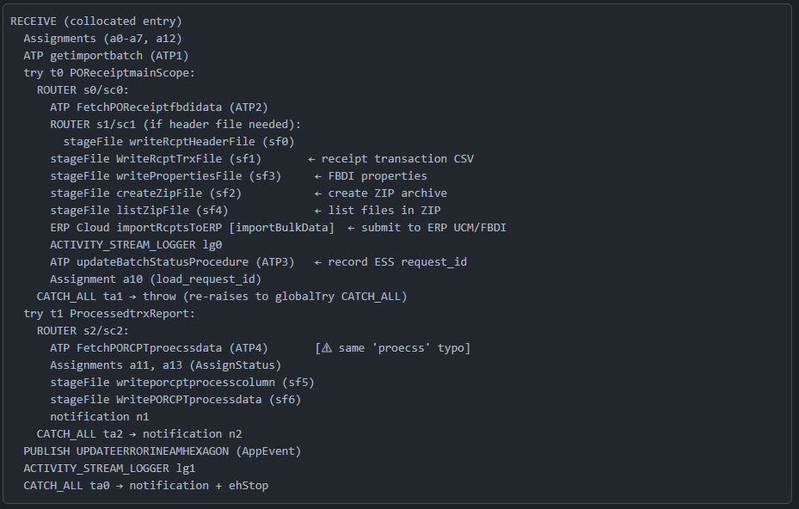FBDI stage files: This is the receipt-specific FBDI package. Two files are written: the receipt header file (writeRcptHeaderFile, optional based on ROUTER condition) and the receipt transaction CSV (WriteRcptTrxFile). The pattern (properties + ZIP + list + importBulkData) is identical to the PO Inbound FBDI pattern.

The updateBatchStatusProcedure stores the ESS requestId in ATP. The FetchPORCPTproecssdata procedure then reads back processed data for the summary report. PUBLISH of UPDATEERRORINEAMHEXAGON fires F7 and then F5 stops — this is fire-and-forget, meaning F5 does not wait for EAM writeback to complete.

F6 · IFP_PO_RECEI_IMPOR_CALLB_REQUE — ERP Import Callback
Trigger: ERP Cloud business event poimportorderscallback (ESS job completion) — SOAP/onEvent via IFP_PO_RECE_ORAC_ERP_CLOU_CONN
Tracking: DOCUMENTID (primary) — from /onEvent/ErpImportBulkDataEvent/DOCUMENTID — the ESS job request ID; tracking_var_2 and tracking_var_3 are unmapped
Flags: projectHasWarnings: true
This is the most complex single flow (3,314-line XML). The structure mirrors IFP_PO_IMPOR_CALLB_16_FEB from PO Inbound precisely.
Pre-scope:
- STITCH sh2 (global variable init)
- stageFile sf8 writerequestidfilercpt — writes the ESS request ID to a stage file for traceability
- Assignments
ScopePrioritywisebatch [try t0] — chain-continuation logic:
- ATP getprioritywisenextbatch (ATP1) — fetches the next queued batch of the same priority
- ROUTER:
  - sc6 → PUBLISH CALLPRIORITYWISEPORCPT — triggers the next batch in the priority queue
  - sc7 → ACTIVITY_STREAM_LOGGER — logs when no more batches in queue
- CATCH_ALL: ehStop
This creates a chain-fire pattern: after each ERP import callback completes, F6 immediately triggers the next priority batch. The batches process sequentially per priority group.

MainScope [try t1] — 3-route ROUTER [s0]:
Route | Condition | BIP SOAP calls | ATP inserts
sc0 | New import results | SOAP1 callBIPReport → SOAP3 callImportDetailsReport | ATP2 updateimportrequestid + ATP4 insertpoerroratp + ATP6 POerrordetailsrpt + ATP8 insertImportDetailsintoATPDB + ATP9 callImportDetailsProcedure
sc1 | Extended/alternate report | SOAP2 callErrorReport → SOAP4 (callImportDetailsErrorReport) | ATP3 updateimportrequestid + ATP5 insertImportDetailsintoATPDB + ATP7 POerrordetailsrpt + ATP10 insertImportDetailsError + ATP11 callImportDetailsErrorProcedure
sc8 | ESS status-only / no processable report | ERP Cloud2 DonloadZIPFile [⚠ Donload typo — shared with PO Inbound] → stageFile sf11 + notification | —

ProcessedtrxReport [try t2] (runs after all routes):

- ATP FetchPORcptproecssdata (ATP12) [⚠ same proecss + Rcpt prefix variant]
- stageFile sf9 writeporcptprocesscolumn, sf10 WritePORCPTprocessdata
- Notification email
PUBLISH UPDATEERRORINEAMHEXAGON → fires F7
Global CATCH_ALL: Notification + ehStop

⚠ ESS async gap — same as PO Inbound: If the ERP ESS job fails silently, the ERP Cloud adapter never pushes poimportorderscallback to OIC. F6 never fires. There is no OIC-level timeout watchdog for this gap.

F7 · IFP_EAM_UPDA_MESS_IN_EAM_HEXA — EAM Writeback
Trigger: SUBSCRIBE UPDATEERRORINEAMHEXAGON AppEvent
Connections used: IFP_PO_RECEI_EAM_REST_CONNE (5 REST operations), IFP_PO_RECEI_ATP_DB_CONNE

This flow differs structurally from the PO Inbound EAM writeback. The success path has a two-route ROUTER distinguishing receipt type:

UpdateSuccessEAM [try t1] (runs first):
- ATP GetSuccessPORcpt (ATP1) — fetch successfully imported receipt records
- ROUTER s1/sc1 (if success records exist): FOR each success record [f2]:
  - SwitchLogicForServices [try t3] — ROUTER s3:
    - sc3 (PO receipt): REST UpdateEAMPOReceiptSuccessStatus (REST4) → ATP SentEAMUpdateinDB (ATP4)
    - sc4 (Service receipt): REST ServiceReceiptUpdate (REST5) → ATP SentUpdateEAMinDB (ATP5)
  - CATCH_ALL ta2 → ACTIVITY_STREAM_LOGGER lg2

UpdateEAMError [try t0] (runs after success scope):
- Assignments a0, a1 (Assign_org_tenant)
- ATP GetPOReceiptErrorRecords (ATP2) — fetch header-level error records
- ROUTER s0/sc0 (if errors exist): FOR each error header [f0]:
  - ROUTER s2/sc2 (EAMHeaderErrorAPIScope [try t4]):
    - REST UpdateEAMPOReceiptStatus (REST3) — update overall PO receipt status to ERROR
    - REST EAMHeaderErrorAPI (REST1) — push header error detail to EAM
    - ATP StatusUpdationEAM (ATP7) — record status
    - CATCH_ALL ta0 → ACTIVITY_STREAM_LOGGER lg0
  - ATP GetPOReceiptLineErrors (ATP3) — fetch line-level errors for this header
  - FOR each error line [f1] (EAMLineErrorLogsAPI [try t2]):
    - REST EAMLineErrorAPI (REST2) — push line error detail to EAM
    - ATP UpdateEAMStatus (ATP6) — record line status
    - CATCH_ALL ta1 → ACTIVITY_STREAM_LOGGER lg1
STOP
Key structural observation: Unlike PO Inbound's F8 which fires twice (once from F5, once from F6), F7 here fires only once per UPDATEERRORINEAMHEXAGON event. However, F7 receives events from 4 possible publishers (F5, F6, IFP_PO_RECEI_IMPOR_CALLB_REPRO, IFP_EAM_UPDA_MESS_IN_EAM_HEXA_RE), so multiple concurrent F7 instances per batch are possible if both F5 and F6 publish for the same BATCH_ID without guard logic in the ATP query procedures.

Section 5 — Reprocess and Manual-Trigger Flows (4 Flows)
These 4 flows provide operational re-entry points into the pipeline at specific stages. This is a significantly stronger reprocess capability than PO Inbound.
Flow | Trigger endpoint | Re-entry point | What it does
IFP_EAM_PRIORITY_REPROCES | REST getprioritywise (params: pbatchid, pimportid) | Re-publishes CALLPRIORITYWISEPORCPT | Two routes: direct publish OR ATP PORCPTpriority reset then publish. Enables priority adjustment before re-trigger.
IFP_EAM_UPDA_MESS_IN_EAM_HEXA_RE | REST UpdatemessageinEAM (param: pbatchid) | Re-publishes UPDATEERRORINEAMHEXAGON | Single-step re-trigger of F7 EAM writeback only. Simplest reprocess.
IFP_PO_RECEIP_REPROC_INTEGR | REST getporcptreprocess (params: pbatchid, preceiptnum) | ATP updateporcptdata + COLLOCATED → F4 | Receipt-level reprocess: resets status for one receipt, then re-enters at validation (F4).
IFP_PO_RECEI_IMPOR_CALLB_REPRO | REST callbackreprocess | ATP getprioritywisenextbatch + full BIP processing + PUBLISH UPDATEERRORINEAMHEXAGON | Full callback reprocess: re-runs BIP report fetch and ATP inserts exactly as F6, then re-triggers EAM writeback.

Section 6 — ATP Stored Procedure Inventory
Flow | Proc Name | Purpose
F1 | EAMReceiveHdrInsert | Insert receive header grid rows
F1 | EAMRecieveLineInsert | Insert receive line grid rows [Recieve typo in name]
F1 | EAMReturnHdrInsert | Insert return header grid rows
F1 | EAMReturnLineInsert | Insert return line grid rows
F1 | InsertServiceStageloaddata | Insert service receipt/return grid rows
F1 | Insertintoextractloadtable | Record in extraction load tracking table
F1 | poRcptinboundbatchupdcre | Create batch record
F1 | PORCPTprior | Set batch priority
F1 | ReceiveHeaderException | Log receive header extraction error
F1 | ReceiveLineException | Log receive line extraction error
F1 | ReturnHeaderException | Log return header extraction error
F1 | ReturnLineException | Log return line extraction error
F1 | ServiceException | Log service receipt extraction error
F1 | BatchCreationException | Log batch creation failure
F2 | BatchstatusDRAFTupd | Set batch status to DRAFT
F3 | mainstageload | Main staging transformation procedure
F3 | updateReadybatchstatus | Set batch status to READY
F4 | fecthBUbatchlastrundetails | Fetch BU last-run timestamps [⚠ fecth typo]
F4 | POreceipt | Insert BIP PO receipt report data
F4 | loadPOsupplierdet | Insert BIP supplier detail data
F4 | loadInvItemdetailsrpt | Insert BIP inventory item data
F4 | updatelastrundate | Update BU last-run date after reports
F4 | PORcptValidation | Main receipt validation procedure
F4 | UpdateInprocessbatchstatus | Set batch to IN-PROCESS
F5 | getimportbatch | Fetch batch ready for import
F5 | FetchPOReceiptfbdidata | Fetch FBDI-ready receipt data
F5 | updateBatchStatusProcedure | Update status + store ESS request_id
F5 | FetchPORCPTproecssdata | Fetch processed receipt summary [⚠ proecss typo]

Continued…
Flow | Proc Name | Purpose
F6 | getprioritywisenextbatch | Fetch next queued batch for chain-fire
F6 | updateimportrequestid (×2) | Store ESS request ID against batch (Route 0 and Route 1)
F6 | insertpoerroratp | Insert import error rows from BIP
F6 | POerrordetailsrpt (×2) | Call import error detail procedure
F6 | insertImportDetailsintoATPDB (×2) | Insert import detail rows from BIP
F6 | callImportDetailsProcedure | Finalize import detail processing
F6 | insertImportDetailsError | Insert extended error detail rows
F6 | callImportDetailsErrorProcedure | Finalize error detail processing
F6 | FetchPORcptproecssdata | Fetch processed data for report [⚠ proecss typo]
F7 | GetSuccessPORcpt | Fetch successfully imported receipts
F7 | SentEAMUpdateinDB | Record PO receipt success writeback sent
F7 | SentUpdateEAMinDB | Record service receipt success writeback sent
F7 | GetPOReceiptErrorRecords | Fetch error header records
F7 | GetPOReceiptLineErrors | Fetch error line records
F7 | StatusUpdationEAM | Record EAM header error status
F7 | UpdateEAMStatus | Record EAM line error status
Reproc | PORCPTpriority | Reset/assign priority for reprocess
Reproc | updateporcptdata | Reset receipt status for reprocess

Section 7 — Implementation Issues and Defects
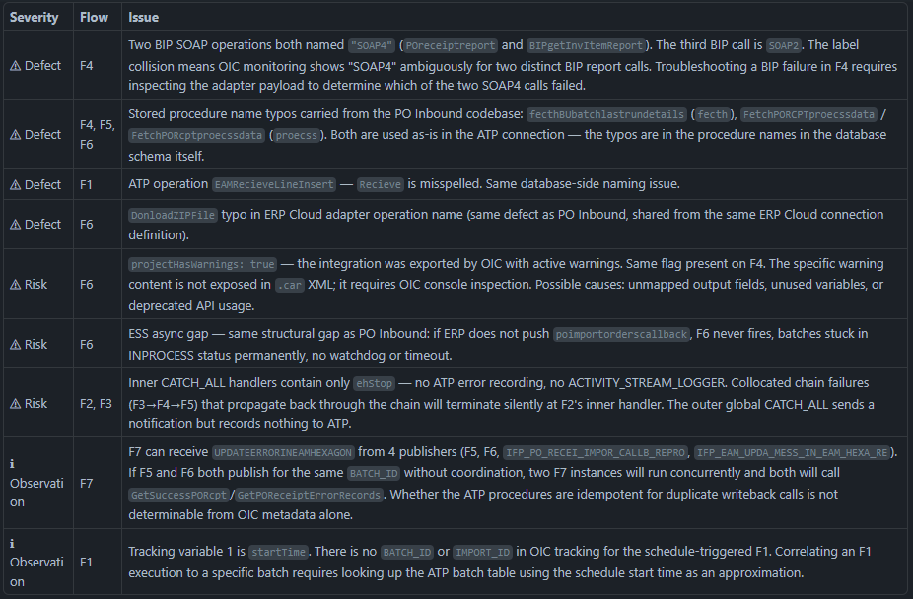

Section 8 — Comparison with IFP_PO_INBOUN_INTEGR_ATP

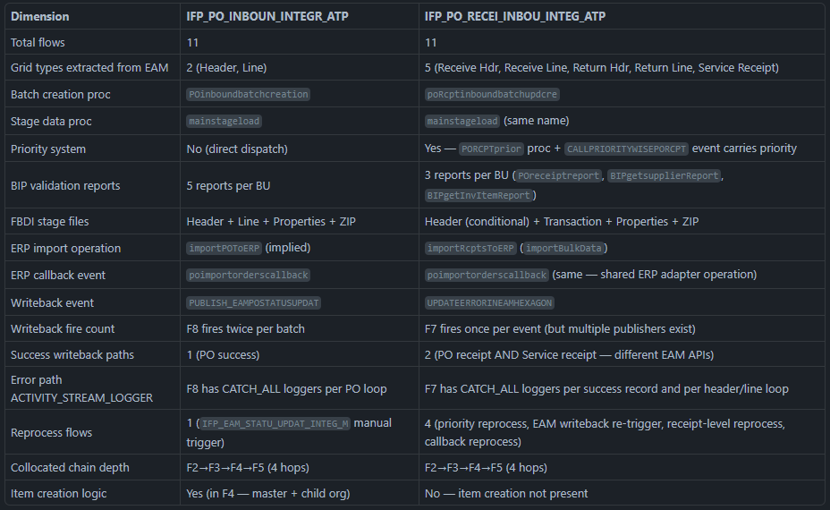
That is the complete technical analysis for IFP_PO_RECEI_INBOU_INTEG_ATP. Summary of what was established:
11 flows in 3 categories:
- 7 core pipeline flows: DATA_EXTR (scheduled) → BATC_PROC (AppEvent) → STAG_DATA_LOA → VALID_INTEG → IMPORT_INTEGR → IMPOR_CALLB_REQUE (ERP callback) → UPDA_MESS_EAM_HEXA (AppEvent)
- 4 reprocess flows: priority reprocess, EAM writeback re-trigger, receipt-level re-entry, callback reprocess
Key findings:
- F4 naming defect — two BIP SOAP operations both named SOAP4 in the validation flow; breaks OIC monitoring clarity
- projectHasWarnings on F4 and F6 — exported with OIC warnings, cause requires console inspection
- ESS async gap on F6 — same structural risk as PO Inbound (no timeout watchdog for ERP callbacks)
- Silent inner CATCH_ALL on F2/F3 — collocated chain failures terminate silently
- Dual-publisher race risk on F7 — F5 and F6 can both publish UPDATEERRORINEAMHEXAGON for the same batch without guard logic
- Service receipt routing — F7 uniquely distinguishes PO receipts from service receipts (different EAM REST APIs per type)

